CN LAB 2 Laiba Fatima 22K-5195
Task 1
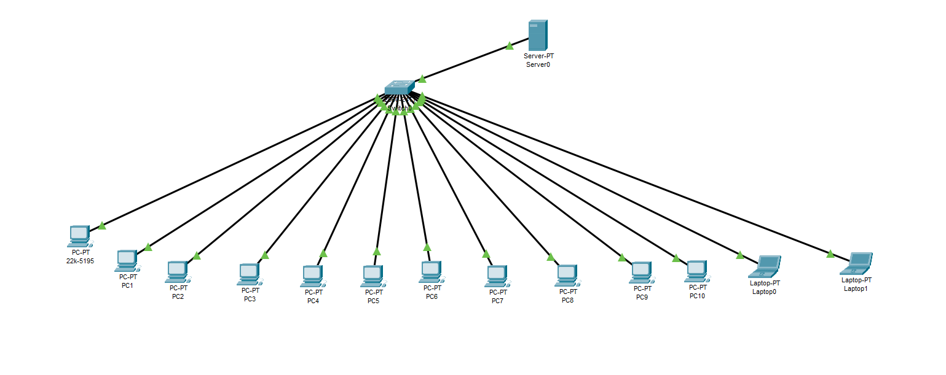
This design ensures addition of future devices with minimal changes as every new device has to be connected only to the switch to be connected to the server or communicate with each other.
Task 2

Task 3
- Hub broadcasts data to all devices, Switch is unicast and sends data to one device
- Logical mode refers to memory addresses used by programs, which are managed by the CPU and OS, requiring translation to physical addresses. Physical mode, on the other hand, deals with actual memory locations in RAM.
- 1.Straight 2. Crossover 3. Crossover
Task 4
A bridge is a network device that connects and filters traffic between two or more network segments, reducing collisions and improving performance. The bridge learns MAC addresses of connected devices in each segment and maintains a table and forwards data only to the intended recipient, rather than broadcasting it to all devices. This helps in segmenting a network and reducing congestion while maintaining communication between different segments. A bridge is an older, simpler device that connects network segments, while a switch is a more advanced, high-performance device that improves network efficiency by isolating collision domains per port.

Task 5

